

Maintain control of all your content

Foxit PhantomPDF Quick Guide

Quick Guide
1

More

Foxit® PhantomPDF™ Quick Guide

This guide gives you a brief introduction to the main features of Foxit PhantomPDF. For detailed instructions, please refer to our user manual.

Getting Started

Installing Foxit PhantomPDF

System Requirements
Operating Systems
- Windows 7 (32-bit & 64-bit).
- Windows 8.x Full Version.
- Windows 10.
- Microsoft Office® 2007 or later version (required for some PDF creation features).
- Verified as Citrix Ready® with Citrix XenApp® 7.13.

Recommended Minimum Hardware for Better Performance
- 1.3 GHz or faster processor.
- 512 MB RAM (Recommended: 1 GB RAM or greater).
- 2G of available hard drive space.
- 1024*768 screen resolution.

How to Install

The installer format of Foxit PhantomPDF is MSI. Please download the installer to your computer, and then do the following (Take Business Edition for example):

- Double click the “FoxitPhantomPDF_Business_enu_Setup.msi” file, and you will see the setup wizard pop up. Click Next to continue.
- Foxit PhantomPDF is protected by copyright law, so in order to proceed, you must accept the License Agreement. Check the I accept the terms in the License Agreement box to continue.
- There are two installation setup types for Foxit PhantomPDF. The user has the ability to change the installation directory or to keep the default settings.
Typical — Installs all features by default, which requires more disk space.
Custom — Allows users to choose which program features will be installed.
- For Typical Setup, just click Install. For Custom Setup, do the following:
  - Click on “Browse” to change the installation directory of the PDF Viewer plug-in.
  - Click “Disk Usage” to check the disk space available for the selected features.

  - Check the options you want to install and click “Next” to continue.
  - Select the additional tasks you would like the Setup to perform, then click “Install” to start the installation.
- When the process is complete, a dialog box will notify the user that Foxit PhantomPDF is installed. You can choose to check the Launch Foxit PhantomPDF box to run the application right after installation. Click Finish to complete the installation.

Command-line Installation

You can also use the command-line to install the application:
msiexec /Option <Required Parameter> [Optional Parameter] [PROPERTY=PropertyValue]

For more detailed information on msiexec.exe, as well as required and optional parameters, type “msiexec” in the command line or visit Microsoft TechNet Help Center.

Public Properties of the Foxit PhantomPDF MSI Installation Package.
Foxit PhantomPDF installation properties supplement the standard MSI public properties to give administrators greater control over the installation of the application.
For the complete list of standard public properties, please refer to: http://msdn.microsoft.com/en-gb/library/aa370905(VS.85).aspx The Foxit PhantomPDF properties are:
---------------------------------------------------------------------------------------------------------------
ADDLOCAL <list of features> The value of the ADDLOCAL property is a comma-delimited list
of features that the installation of Foxit PhantomPDF will make locally available. Foxit PhantomPDF installer is composed of the following features:
FX_PDFVIEWER - Foxit PDF Viewer and its components.
FX_FIREFOXPLUGIN – A plugin used for opening PDF files in Mozilla Firefox, Opera, Safari, and Chrome browsers. This feature requires FX_PDFVIEWER to be installed.
FX_EALS – A module used for displaying Eastern Asian Languages. Eastern Asian Languages can't be displayed properly without it. This feature requires FX_PDFVIEWER to be installed. FX_SPELLCHECK - A tool used for searching any misspelled words in typewriter or form filler mode. This tool also suggests the correct spelling for common mistakes. This feature requires FX_PDFVIEWER to be installed.
FX_PDFA – A module used for verifying compliance with PDF/A- 1a and PDF/A-1b. This feature requires FX_PDFVIEWER to be installed.
FX_OCR – A module used for making scanned or image-based PDF documents selectable and searchable. This feature requires FX_PDFVIEWER to be installed.
FX_CREATOR - Foxit PhantomPDF Creator installs a virtual

printer on your system. Creator can convert any printable documents into high-quality PDFs conveniently and efficiently. This feature requires FX_PDFVIEWER to be installed.
FX_CONVERTEXT - Shell extension used for converting PDFs or combining supported files from the right click menu. This feature requires FX_CREATOR to be installed.
FX_CREATORWORDADDIN - MS Word toolbar add-in to create PDFs in just one click. This feature requires FX_CREATOR to be installed.
FX_CREATOREXCELADDIN - MS Excel toolbar add-in to create PDFs in just one click. This feature requires FX_CREATOR to be installed.
FX_CREATORPPTADDIN - MS PPT toolbar add-in to create PDFs in just one click. This feature requires FX_CREATOR to be installed.
FX_CREATOROUTLOOKADDIN - MS Outlook toolbar add-in to create PDFs in just one click. This feature requires FX_CREATOR to be installed.
FX_SE - Plugins for Windows Explorer and Windows shell. These extensions allow PDF thumbnails to be viewed in Windows Explorer, and PDF files to be previewed in Windows OS and Office 2007 (or a later version). This feature requires FX_PDFVIEWER to be installed.
FX_IFILTER – Foxit PDF IFilter is a plugin for Windows search engines that can help search PDF documents quickly.
FX_CONNECTEDPDF – A plugin that provides ConnectedPDF features including creation, sharing, securing, and tracking of PDF documents worldwide.
FX_BROWSERADDIN - The web browser plugin used for converting web pages to PDFs.
INSTALLLOCATION Specifies the folder location of the product installed.
MAKEDEFAULT Default value of "1", Foxit PhantomPDF will be set as the
default application for opening PDF files.
VIEW_IN_BROWSER Default value of "1", Foxit PhantomPDF will be configured to
open PDF files inside browsers.
DESKTOP_SHORTCUT Default value of "1", installer will place a shortcut for the
installed application on the Desktop.
STARTMENU_SHORTCUT Default value of "1", installer will create a program menu group
for installed application and its components.
SETDEFAULTPRINTER Default value of "1", installer will install Foxit PhantomPDF
Printer and set it as the system’s default printer.
LAUNCHCHECKDEFAULT Default value of "1", Foxit PhantomPDF will check if Foxit

PhantomPDF is the default reader when launched.
KEYPATH Specifies a license key file and saves it to the PhantomPDF installation folder.
REMOVENEWVERSION Forces an installation to overwrite the newer version of Foxit
PhantomPDF with the value of “1”.
CLEAN Executes with the command “/uninstall”, removing all of PhantomPDF’s registry data and related files with the value of “1”. (Note: This is a command for uninstallation.)
AUTO_UPDATE Does not download or install updates automatically with the
value of “0”; Automatically checks for updates and downloads updates if any, but lets users choose when to install them with the value of “1”; Automatically installs updates with the value of “2”. The default value is “1”.
CPDF_DISABLE Disables the ConnectedPDF features by setting the value to “1”.
EDITION Specifies an edition to install Foxit PhantomPDF, including
Standard and Business.
NOTINSTALLUPDATE Does not install updates by setting the value to “1”. This will
prevent Foxit PhantomPDF from being updated from within the software.

INTERNET_DISABLE Disables all features that require Internet connection by setting
the value to “1”.

READ_MODE Opens PDF file in Read Mode by default in web browsers by setting
the value to “1”.

DISABLE_UNINSTALL_SURVEY Stops the Uninstall Survey after uninstallation by setting the
value to “1”.

KEYCODE Activates the application by key code.

EMBEDDED_PDF_INOFFICE With the value of “1”, opens embedded PDF files in Microsoft
Office with Foxit PhantomPDF if Acrobat and Foxit Reader is not installed. (For the EXE installation package, inputs the command- line /displayadobeindoc.)

Command-line Examples:

- Silently install the application (no user interaction) to folder "C:\Program Files\Foxit Software":

msiexec /i "Foxit PhantomPDF.msi" /quiet INSTALLLOCATION="C:\Program Files\ Foxit Software "

- Install the Foxit PDF Viewer only:

msiexec /i "Foxit PhantomPDF.msi" /quiet ADDLOCAL="FX_PDFVIEWER "

- Use the license key file saved in disk C to activate the application when running the setup: msiexec /i "Foxit PhantomPDF.msi" KEYPATH="C:\fpmkey.txt"
- No installation of Foxit PhantomPDF Printer:

msiexec /i "Foxit PhantomPDF.msi" ADDLOCAL=ALL, ADVERTISE="FX_CREATOR" /qn

- Force an installation to overwrite the same or higher version of Foxit PhantomPDF: msiexec /i "Foxit PhantomPDF.msi" REMOVENEWVERSION="1"
- Remove registry and user data when performing silent uninstallation: msiexec /x "Foxit PhantomPDF.msi" /quiet CLEAN="1"
- Install the application without ConnectedPDF related features and services:

msiexec /i "Foxit PhantomPDF.msi" ADDLOCAL=ALL, ADVERTISE="FX_CONNECTEDPDF"

- Activate the application by key code:

msiexec /i "Foxit PhantomPDF.msi" KEYCODE="your key code"

- Install the application without Foxit PhantomPDF Create PDF Toolbar

msiexec /i "Foxit PhantomPDF.msi" ADDLOCAL=ALL, ADVERTISE="FX_BROWSERADDIN"

Activating Foxit PhantomPDF

- After installing Foxit PhantomPDF, the activation wizard pops up. If you have already purchased a license for Foxit PhantomPDF, click Activate to register your license key. If not, you can click Buy Now to purchase Foxit PhantomPDF from the Foxit website. If you choose Free Trial, you will be given a 14-day free trial period to use Foxit PhantomPDF. When the free- trial period expires, only the free features are available.
- After you click Activate, the box will prompt you to input the code of the registration key. You can activate the key at a later time from Help > Activate when you run Foxit PhantomPDF. Then click Activate to continue.
- (Optional) If you didn’t provide your name when purchasing the license, you’ll be prompted to type your name.
- If the activation is successful, a message box will pop up. Click OK.
- You should restart the application for the changes to take effect. To restart it now, please click

OK; or click Cancel to restart later.

Deactivating Foxit PhantomPDF

You can deactivate Foxit PhantomPDF on one machine in order to activate on another. After deactivation, you can still use the features of Foxit PhantomPDF Express. To deactivate Foxit PhantomPDF, click Help > Deactivate.

Uninstalling Foxit PhantomPDF

How to Uninstall

Please do one of the following:

Click Start > All Programs > Foxit PhantomPDF > Uninstall.

For Windows 8 and 10, click Start > Windows System > Control Panel > Programs > Programs and Features > Select Foxit PhantomPDF and click Uninstall. For Windows 7, click Start > Control Panel > Programs and Features to uninstall it.
Double click the file uninstall.exe under the Foxit PhantomPDF installation directory drive name: \...\Foxit Software\Foxit PhantomPDF\.

Using Foxit PhantomPDF

- File menu
- Skin and Toolbar
- Move around the documents and select things
- See all the different commands
- Standards Validation and Creation
- Integrate with Foxit PDF IFilter

File menu

The functions Open, Save, Print, Action Wizard, and other basic tools can be accessed by clicking the File menu, and then selecting them from the drop-down menu. Click Open to open PDFs in your local drives or cloud servers including SharePoint, OneDrive, Google Drive, and more. To check the document properties, select the file menu and go to Properties. To change Program settings select Preferences.

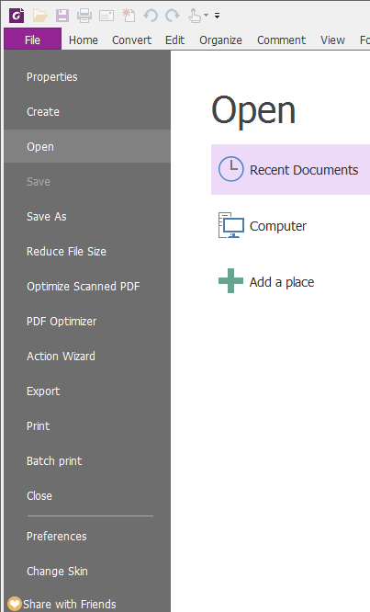

Skin and Toolbar

There are five kinds of skins, Classic, Black, Blue, Orange and Purple that allow the user to change the look of the software. To change the skin of the workspace, choose File > Change Skin > Select the desired skin from the list.

Ribbon Mode

The Ribbon Mode is an interface with a set of toolbars placed in categories on a tabbed bar. A ribbon provides the user interface of an application with a large toolbar filled with graphical representation of control elements, which are grouped by functionality. Foxit PhantomPDF’s Ribbon Mode groups commands by task, eliminating the need for many different icon-based toolbars, while ensuring the commands used most frequently are close at hand.
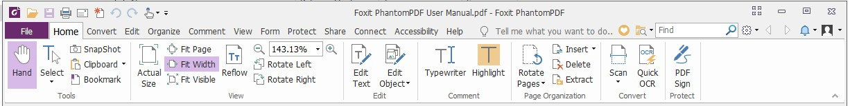

(Business Edition)

Show/Hide the Ribbon

Click or in the upper right corner to collapse/expand the toolbar.

Move around the documents and select text, image or annotations
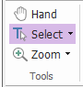

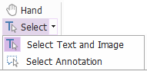

The four most useful commands for navigating and interacting with PDFs are Hand, Select Text and Image, Select Annotation, and Zoom. The Hand command lets you scroll through the PDF, respond to links, fill in forms, and play multimedia files. The Select Annotation command allows you to select multiple annotations and then move, resize, or align them together. The Select Text and Image command lets you select text or image to copy, edit, add annotations, or manage bookmarks. The Zoom command lets you zoom in or out the page easily for better reading experiences.

See all the different commands

Home Tab in Business Edition

Click the buttons in the ribbon under different tabs to switch between different commands. Also, the tooltip appears when the pointer is held above each command. For instance, there are Tools, View, Edit, Comment, Page Organization, Convert and Protect groups that are all most frequently used under the Home tab. You can use these text and annotation command to move around and interact with PDFs, zoom in/out pages, edit page contents, manage comments, organize pages, scan and OCR, place signatures, and perform other basic functions.

To quickly find a command you need, click in the Tell me what you want to do… box (or press Alt
+Q) near a bubble on the menu bar and type the name or description of the command. Then
Foxit PhantomPDF will display a list of matching commands from which you can select and activate the desired feature.

Industry Standards Validation and Creation



With the Industry Standard command in Foxit PhantomPDF, you can specify the PDF’s standards

for specific industries and functions. Foxit PhantomPDF has PDF/A, PDF/E and PDF/X compliance validation and creation to meet industry standards. Select Convert > Compliance > Industry
Standard, then select one of the industry standards, and then click Analyze or Analyze and Fix
in the pop-up dialog box. You can also create standard compliant PDFs by saving them as PDF/X, PDF/A or PDF/E with Foxit PhantomPDF Business.

Integrate with Foxit PDF IFilter

Foxit PhantomPDF is now packaged with Foxit PDF IFilter for Desktop, which allows users to index a large amount of PDF documents and then quickly find text within these documents on a desktop system. You can trigger Foxit PDF IFilter in the installation directory of Foxit PhantomPDF.

Document Views

Single-tab Reading and Multi-tab Reading

Single-tab reading mode allows you to open PDF files in multiple instances. This is ideal if you need to read your PDFs side by side. To enable single-tab reading, go to File > Preferences > Documents, check the Allow multiple instances option in the Open Settings group, and click OK to apply the setting.
Multi-tab reading mode enables users to open multiple PDF files in different tabs in the same instance. To enable multi-tab reading, go to File > Preferences > Documents, uncheck the Allow multiple instances option in the Open Settings group, and click OK to apply the setting. In multi- tab reading mode, you can drag and drop a file tab outside of the existing window to create a new instance and view the PDF file in that individual window. To recombine the file tab to the main interface, click on the file tab and then drag and drop it in reverse to the main interface.

Switch between Different View Modes

You can view documents with text only, or view them in Read mode, Full Screen, Reverse View, Reflow mode, and Night Mode.

Go to Specified pages

Click the First Page, Last Page, Previous Page and Next Page in the Go To group under the View tab or in the status bar to view your PDF file. You can also input the specific page number to go to that page. The Previous View lets you return to the previous viewed instance and Next View goes to the next viewed instance.
To jump to a topic using bookmarks, click the Bookmark button on the left Navigation pane. And then click the bookmark or right-click the bookmark and choose “Go to Bookmark”.

Click the plus (+) or minus (-) signs to expand or collapse the bookmark contents.
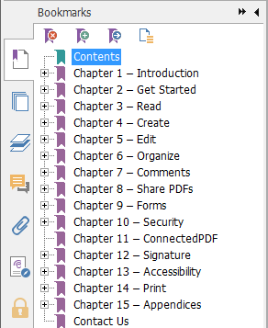

To jump to a page with page thumbnails, click the Page Thumbnails button on the left Navigation pane and click its thumbnail. To move to another location on the current page, drag and move the red box in the thumbnail. To resize a page thumbnail, right-click on the thumbnail and choose “Enlarge Page Thumbnails” or “Reduce Page Thumbnails”.

Change the way the document is displayed

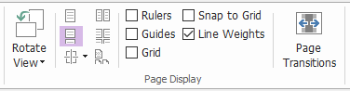

The Page Display Commands

Foxit PhantomPDF offers a number of different ways to view the pages of a PDF, customized to your preference. Under the View tab, you can choose the following page layouts: Single Page, Facing, Continuous, Continuous Facing, Split, and Separate Cover Page.

Adjust the page magnification
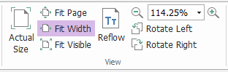

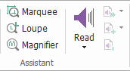

The View Commands

Click Home tab and choose the commands in the View group.

  - Click Zoom In or Zoom Out to increase or decrease the magnification of the

document.
  - Click Fit Page to see an entire page on screen, Fit Width to make the page fill the width of the screen, Fit Visible to fit only the visible area of the page, and Actual Size to return the page to its actual size.
  - Click Rotate Right/Left to rotate the page view clockwise/counterclockwise in 90-degree increments.

Under the View tab, you may choose the following commands in the Assistant group:

- Click the Marquee Zoom command to enlarge an entire page. Click and drag this command to enlarge an area of the page.
- Click the Loupe command and move it to the location on the page you want to view,
and you will see that specific location amplified or diminished in the Loupe command dialog box.
- Click and move around the Magnifier command to easily magnify areas of the PDF.

Read Out Loud
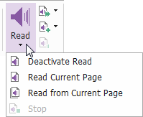

Read Out Loud is a Text-to-Speech (TTS) tool. It reads the text in a PDF aloud, including the text in comments and alternate text descriptions for images, tables, and fillable fields. Text is read based on the order of the page content. (Note: Read Out Loud isn’t a screen reader, it may not be available in some operating systems.)

You need to select View > Assistant > Read > Activate Read to activate Read Out Loud before using it. Then navigate to the page that you want to read out and choose View > Assistant > Read > Read Current Page or Read from Current Page. While reading, you can interrupt the reading and adjust reading volume and speed as needed.

Compare PDF

The Document Compare feature lets you see the differences between two versions of a PDF, as well as select the type of differences you’re looking for to verify that the appropriate changes have

been made. The Document Compare feature does not compare comments in the PDF.
Choose View > Review > Compare to choose files and select comparing options in the Compare PDF Files dialog box.

Create & Export

Foxit PhantomPDF gives you almost unlimited options to create PDFs, as well as create 3D PDF files from .dwg and .dxf files. In the Convert tab, you can directly create PDFs from specific files, a blank page, a web page, a scanner, or from the clipboard. You may also create PDF portfolios, as well as export PDFs to images, MS office, HTML and more.
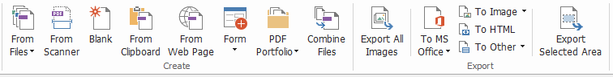

The Create and Export Groups

- Create PDF with one-click
- Create PDF from Microsoft Office
- Create PDF from Microsoft Visio (Business Only)
- Create PDF using the Print command
- Create PDF using Print to Evernote
- Create a PDF using Scanner
- Create a PDF within web browsers
- Create PDF Portfolios
- Export PDF all images
- Export PDF to Image, MS Office, HTML and others

Create PDF with one-click

To create a PDF with one click:

- Drag the document you want to convert onto the Foxit PhantomPDF desktop icon .
- If Foxit PhantomPDF is open, drag and drop the file directly into the application window.
- Right click the document icon you want to convert and choose Convert to PDF in Foxit PhantomPDF.

Foxit PhantomPDF also allows you to quickly create PDFs from blank pages, the clipboard, webpages, and create a PDF form from an existing file, with commands in File > Create or under the Convert tab. When creating from webpages, you can choose to convert the entire website or a specified number of levels of the website, and set more options like timeout, hyperlinks, and more.

Create PDF from Microsoft Office

Foxit PhantomPDF enables you to create professional and secure PDF files directly from Microsoft Office applications (Word, Excel, PPT and Outlook). Creating PDFs from Microsoft Word automatically retains bookmarks, links, outlines, and other settings during conversion.

Foxit PhantomPDF also allows you to convert personalized email messages, letters, or labels created from Microsoft Word’s Mail Merge function into PDFs all at once. You can also change the settings to send the PDFs via email attachments to a number of individuals if needed.

Create PDFs in Microsoft Visio (Business Only)

PhantomPDF Creator Plugin in Microsoft Visio provides quick and easy PDF creation from Visio files, while preserving the document properties in the created PDFs depending on the conversion settings.

Create PDF using the Print command

- Open the file.
- Select File > Print from the main menu.
- Select Foxit PhantomPDF Printer from the Printer list.

Create a PDF using Print to Evernote

Foxit PhantomPDF adds a new printer “Print to Evernote” after installation. This feature enables the user to send the PDF file as an attachment to Evernote, as well as the option to create a PDF the same as Foxit’s PDF printer does.
To create a PDF using Print to Evernote, see below:
- Install the Evernote application and sign in to an Evernote account.
- Open the file you want to convert to PDF, and choose File > Print > Print to Evernote.
- Set the print properties and then click Print. Name the PDF file and specify the storage location.
- You will see that the PDF file is created and attached in Evernote.

Create a PDF using Scanner

Foxit PhantomPDF allows you to create a PDF directly from a paper document using your scanner. You can scan a document to PDF directly with custom settings or by using preset preferences that you configured before.

To scan a document to PDF with custom settings, use the following options: 1) File > Create > From Scanner > the From Scanner… button, 2) Choose Convert > Create > From Scanner, or 3) Choose Home > Convert > Scan.

To scan a paper document to PDF using a configured preset, select a preset to scan documents

under the Home > Convert > Scan.

Foxit PhantomPDF supports size optimization of scanned PDFs during PDF creation from a scanner, also by choosing File > Optimize Scanned PDF in an existing scanned or image-based PDF.

Create a PDF within web browsers

Foxit PhantomPDF allows you to convert webpages to PDFs using the Foxit Convert tools in the toolbar within Google Chrome, Internet Explorer, and Firefox. You can convert the current webpage to a new PDF or append to an existing PDF, or send the new PDF as an email attachment with one click.

Create PDF Portfolios

Foxit PhantomPDF lets you quickly create a new PDF portfolio with existing files or folders by choosing Convert > Create > PDF Portfolio > Create a new PDF Portfolio, or by creating a blank PDF portfolio and adding files or folders by selecting Create a blank PDF Portfolio.

Export all images in the PDFs

With one click of “Export All Images”, Foxit PhantomPDF enables you to export all images in your document to separate image files. Please click Convert > Export > Export All Images, and configure the settings before exporting via the Export to Images dialog box.

Export PDF to Image, MS Office, HTML and others

- Click Convert tab.
- Select the To Image, To MS Office, To HTML, or the To Other button to convert PDFs to the format desired.
- You can click Settings in the Save As dialog box to change the page range and layout preferences. Then click the Setting Language button to select the language you want to export the file with.

Comment

With Foxit PhantomPDF, you can add annotations or draw shapes to PDF files as you do to a paper document using the commenting, markup, and drawing commands. When you are done, all comments will be organized automatically, and can then be exported for convenient review.

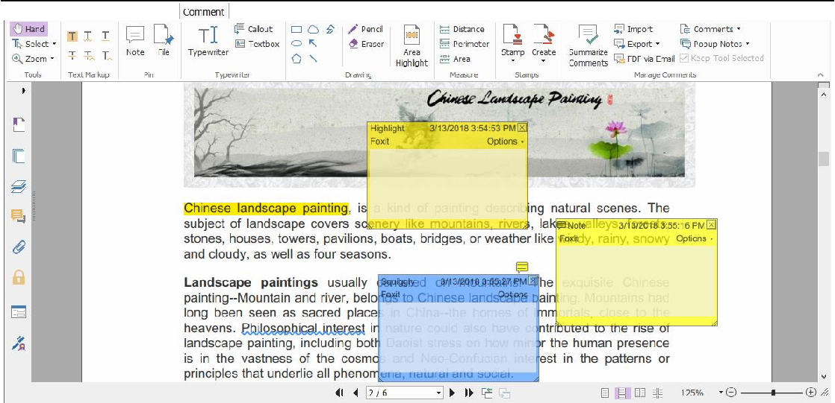

With the Hand command , the Select Annotation command or the corresponding command

selected, right-click a comment and you can choose to set properties, set statuses, reply to comments, and more. You can export and import comment data and summarize comments using the commands in the Manage Comments group. Moreover, if you make comments in a PDF file which is created from a Microsoft Word document, you can easily export the comments to revise the original Word document by choosing Comment > Manage Comments > Export > Export to Word.

Note: You can view, navigate, and comment on the 3D content in PDFs by using the commands in the 3D Content Navigation panel located in the navigation pane.

See comments and attachments

Foxit PhantomPDF keeps organized listing of all comments and attachments in a PDF for easy reference. These are hidden by default to give you the largest possible view of your PDF document. To make them visible, click the Comments or Attachments buttons on the left Navigation pane.
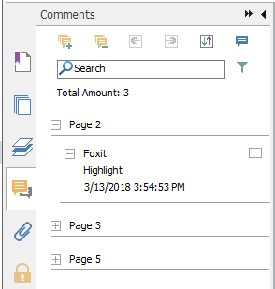

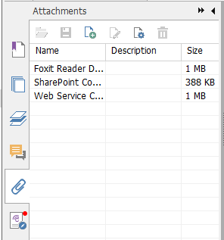

Edit

The Edit Tab in Business Edition
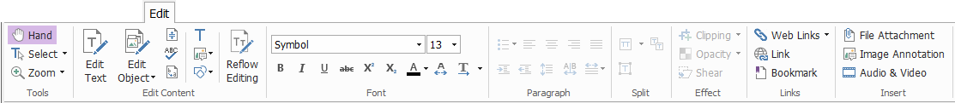

Foxit PhantomPDF lets you easily customize your PDFs by using general editing features to add links, attach files, add images, play and insert multimedia files, and other PDF editor capabilities including layer editing, Search and Replace, and PDF optimizing. Foxit PhantomPDF also provides advanced features to add objects (text, images, path and shading objects) and edit them, including font settings (font, font size, color, underline, etc.), paragraph settings (justify/align left/center/right, character spacing, character horizontal scale, line spacing), style settings, and objects’ splitting and merging.

When you use object editing commands, like the Edit Text command and Edit Object command, and click on text or an object, an Arrange tab appears for more editing features.
- Adding objects – click Add , Add Images , Add Shapes to add objects to the PDFs and change settings if needed.
- Paragraph editing – click Edit Text  and select the paragraphs you want to edit, or just right-click the selected text with the Select Text and Image command and choose Edit Text. You can start a new line by pressing “Enter”. The text wraps automatically when the text being typed flows to the margin of the paragraph box. Also, the text within the paragraph box can reflow automatically and the paragraph box will then automatically rescale.
- Object editing – click Edit Object  and select the object you want to edit. It allows you to change the font, font size/color, and others of the text object. You may also move, resize, delete, or rotate the objects you selected. When you edit image, path or shading objects, the corresponding format tabs will appear.
- Clipping – Clip objects to make desired shapes of objects visible.
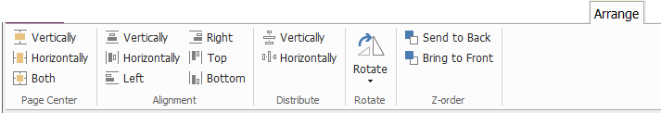

Object Arrange Tab

- Arrange – you can align the PDF content in your PDF file, or arrange them in the center of the page.
- Reflow Editing – click the Reflow Editing command to edit document content in a continuous mode, like in a word processor.

Tip: You can do more actions by right-clicking an object with the Edit Object command.

Organize

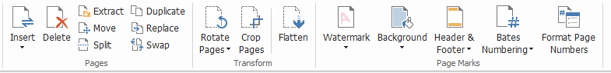

The Organize Tab in Business Edition

Foxit PhantomPDF enables you to directly organize PDF files by inserting/deleting pages, moving/extracting pages, splitting documents, merging pages, re-arranging pages, and composing page outlines. You may also add watermarks, backgrounds, change the header and footer, add bates numbering, and other page marks from the Organize tab. Also, you can drag and drop page thumbnails in the page thumbnail panel to assemble pages in different documents. You can even drag the page thumbnails to the blank areas to extract the selected page(s) as a new PDF file.

Forms

PDF forms streamline the way you receive and submit information. Foxit PhantomPDF allows you to fill in, reset, create, save and submit forms, and more.

- Fill in PDF forms
- Comment on forms
- Work on form data
- Create and edit forms
- Form recognition
- Set calculation order
- About running JavaScript

Fill in PDF forms

Foxit PhantomPDF supports Interactive PDF Form (Acro Form and XFA Form) and Non-interactive PDF Form. You can fill in Interactive forms with the Hand . For non-interactive PDF forms, you can use the Typewriter command ; or you can have Foxit PhantomPDF recognize
form fields with the Run Form Field Recognition command , and then fill in the forms with the Hand command.

Foxit PhantomPDF supports the auto-complete feature, which enables you to fill in PDF forms quickly and easily. It will store the history of your form inputs, and then suggest matches when you

fill out other forms in the future. The matches will be displayed in a pop-up menu.

Note: To use the auto-complete feature while filling in PDF forms, click File > Preferences > Forms, and check Enable Autocomplete. You can also choose to clear the history of your form inputs.

Comment on forms

You can comment on PDF forms, just like any other PDFs. You can add comments only when the form creator has extended these rights to the users. See also Comment.

Work on form data

Click the Import button or Export button in the Form Data group to import/export form

data of your PDF file. This is similar to the way of importing and exporting comment data. You can also export form data to append to an existing CSV file or combine multiple PDF forms to a CSV file. However, this function will only work for PDF interactive forms. Foxit PhantomPDF provides users with the Reset Form command to reset the form. In addition, for PDF forms with Ultraform technology, Foxit PhantomPDF enables users to create and display 2D barcode that contains form data.

Create and edit forms

With Foxit PhantomPDF, you can create interactive forms. You are able to add push buttons, text fields, check boxes, combo boxes, list boxes, or radio buttons to create an interactive PDF form and specify their properties. You can also set a PDF page as a page template, which is very useful in designing extensible forms where users can quickly add the page template to a PDF by creating a button with Java scripts. To make a form more accessible, you can click Add Tooltip to add tooltips automatically for all form fields which does not have descriptions.

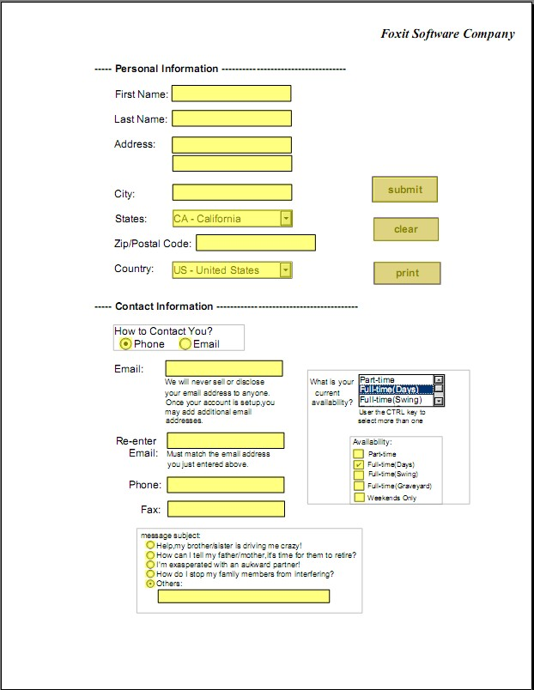
Text Field
Push Button
Combo Box
List Box

Check Box
Radio
Button

A PDF Form

Creating form fields

Here take the Push Button as an example. You can create this button by selecting it in the Form Fields group. You can move, resize, and delete the Push button by selecting the Select Annotation
command. You can set the button properties to determine the button appearance, actions and behaviors, and other form field settings.
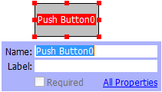
Note: For the radio buttons in a group, they should have the same form field name but with different export values. This ensures that the radio buttons toggle and that the correct values will be collected in the database.

Form Recognition

Foxit PhantomPDF provides Semi-Automated PDF Form Design features for users to easily develop interactive PDF forms. Normally, users need a way to define the form fields directly in their design layout or scanned file. Run Form Field Recognition is an important command and can save the

user’s time in creating interactive PDF forms.

Run Form Field Recognition
Open the PDF file in Foxit PhantomPDF. Click Form tab and select Run Form Field Recognition. Foxit PhantomPDF looks for boxes, underlines, and other cues in your file that indicate a place to enter information and changes them into text fields and check boxes. All fillable fields in the document will be recognized and highlighted.

Note: To run form recognition automatically when a PDF is opened in Foxit PhantomPDF, please click File > Preferences > Forms, and check the option “Run form recognition when creating PDF in PhantomPDF application”.

Inspect and correct the form results with Designer Assistant
Because the recognition process is not always perfect, you’ll need to clean up your forms, add missed fields, adjust default font settings, and other general clean up duties to correct any errors. With the Designer Assistant and other Form Field commands, you can easily complete all the operations above because the Designer Assistant command can inspect corresponding form fields and change the settings automatically. You can modify the name directly in the pop-up box and click “All Properties” to change the settings. See also: Creating form fields.

Note: Click File > Preferences > Forms, check the option “Open simple property box after creating field”.

Set calculation order

When you define two or more calculations in a form, the order in which they are carried out is the order in which you set the calculations. If you want to use the results obtained from calculating two form fields to calculate the value of a third form field, the first two form fields must be
calculated together first to obtain the correct results. Click the Calculation Order  button under the Form tab.

About running JavaScript

With Foxit PhantomPDF, you can invoke JavaScript code using actions associated with documents, bookmarks, links, and pages. Foxit PhantomPDF provides four options: Document JavaScript, Document Action, JavaScript Console, and Edit All JavaScripts. The Document JavaScript lets you create or access document level scripts in Foxit PhantomPDF. The Document Action lets you create document-level JavaScript actions that apply to the entire document. The JavaScript Console provides an interactive and convenient interface for testing portions of JavaScript code and experimenting with object properties and methods. The Edit All JavaScripts option allows you to create and edit all JavaScripts (e.g. bookmark JavaScripts, page JavaScripts, etc.) in the JavaScript Editor.

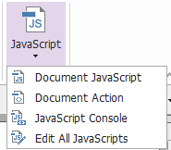

Optional Database connectivity to Windows ODBC

The Optional Database Connectivity plug-in is a JavaScript object inside Foxit PhantomPDF, allowing you to connect to Windows ODBC (Open Database Connectivity) data sources. Also, developers can create document level-scripts to connect to a database for the purposes of inserting new data, updating information, and deleting database entries. Currently, ADBC (Acrobat Database Connectivity) is a Windows only feature and requires Open Database Connectivity (ODBC) provided by Microsoft.

OCR

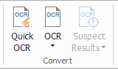

Optical Character Recognition (OCR) is a software process that enables images of printed text to be translated into machine-readable text. OCR is most commonly used when scanning paper documents to create electronic copies, but can also be performed on existing electronic documents (e.g. PDF or PDF portfolio). With Foxit PhantomPDF, you can scan paper documents directly to PDF, and run OCR to make the scanned documents searchable and editable.

OCR Suspects - Foxit PhantomPDF can detect the suspected and mark them in OCR results and allows you to edit the recognition results to improve the accuracy of OCR results. Click Suspect Results under the Convert tab and select First Suspect/All Suspects from the pull-down menu. The Find OCR Suspects dialog box shows both the original document text and the OCR text. You can edit text in the OCR text box directly if needed. If the highlighted text is incorrectly identified, click Not Text. Click Find Next to find the next suspect or click Accept and Find to accept the suspect and find next.

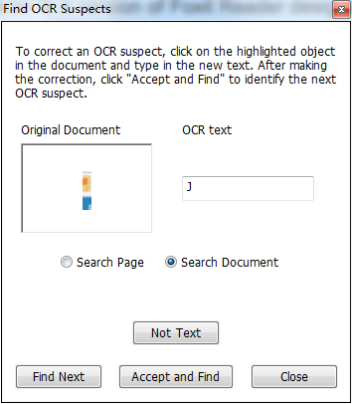
Tip: Foxit PhantomPDF provides the Quick OCR command under the Home/Convert tab for recognizing all pages of a scanned or image-based PDF with the default or previously set settings in just one click.

Share

Foxit PhantomPDF enables users to send PDFs as attachments to others or to their Evernote/OneNote accounts with one-click. Users can also share a document on an internal server or a Foxit Server with others to gather feedback/comments from other reviewers. Integration with SharePoint, NetDocuments, iManage WorkSite, iManage Cloud, Egnyte, OpenText Documentum, OpenText eDOCS, OpenText Content Suite, Worldox, and ShareFile lets users share and manage documents easily within one application.

- Review Documents
- Integration with with SharePoint, NetDocuments, iManage WorkSite, iManage Cloud, OpenText Documentum, OpenText eDOCS, OpenText Content Suite, Worldox, and ShareFile

Review Documents

Shared Review allows document authors to share a document on an internal server or on Foxit Cloud. After receiving the invitation from the review initiator, reviewers can mark-up PDFs using a full set of commenting commands. They will be notified if others add new comments, in which they can reply to these comments. Comments from both the initiator and reviewers will be automatically collected on the internal server or on Foxit Cloud, and then synchronized by Foxit PhantomPDF on a regular interval.

Email Review is useful when reviewers don’t have access to a common server or initiators don’t need collaborative reviews. In an Email Review, the initiator sends PDFs to reviewers as attachments and can view comments only after receiving the commented PDFs back from reviewers. Also, the reviewers can only send back the PDFs after adding comments, without access

to viewing comments made by others.

To send a PDF for review, please choose Share > Review > Send for Shared Review or Send for Email Review. (Business Only)

The review Tracker can help review initiators or reviewers track all comments and manage the whole review process in real time.

If you are collecting comments for a PDF file under shared review or email review which is created from a Microsoft Word document, you can easily export the comments to revise the original Word document by choosing Comment > Manage Comments > Export > Export to Word.

Integration with SharePoint, NetDocuments, iManage WorkSite, iManage Cloud, OpenText eDOCS, OpenText Documentum, OpenText Content Suite, Worldox, and ShareFile
Foxit PhantomPDF enables you to directly open, modify, save, and check out/in PDF documents in your SharePoint, NetDocuments, iManage WorkSite, iManage Cloud, OpenText eDOCS, OpenText Documentum, or OpenText Content Suite account using PhantomPDF, which allows you to streamline your PDF document management. Integration with Worldox and ShareFile also allows you to open, modify, and save PDF document in your Worldox and ShareFile account.

Secure & Sign

Foxit PhantomPDF offers powerful protection for PDF content. You can encrypt and secure PDF files to prevent unauthorized access, restrict sensitive operations, apply digital signature, and more.

The Protect Tab in Business Edition

- Secure document
- Manage security policies
- RMS protector (Available in Business Only)
- About Signature
- Redaction (Available in Business Only)
- Sanitize Document
- Generate Redacted and RMS-protected PDFs (Available in Business Only)

Secure document

In Foxit PhantomPDF, there are three types of security services that control who can access your files, what actions they can perform once they receive them, and who can open a protected document. The three types are Password Protect, Certificate Protect, and Microsoft Windows Rights Management Services Encrypt.

Password Protect: Passwords allow you to limit access and restrict certain features, such as printing, copying, and editing.

- Open password: Users must enter the correct password to open the document.
- Permission password: Lock specific functionality when a user opens your file. For example, you can prevent recipients from modifying or printing your document.

Certificate Protect: The advantage of securing documents with certificates is that authors can specify unique permissions for each person. For example, authors can permit a person to fill in forms and comment in documents, as well as permit another person to edit text or delete pages.

To view the security in a file, select File > Properties > Security, or click the Security Properties
in the Protect tab.

Manage security polices

If you often apply the same security settings to multiple PDFs, you can save your settings as a policy that you can apply to other PDFs. Security policies include the security method, encryption password, permission settings, and other security settings. To manage this, click the Security
Policies in the Protect ribbon.

RMS Protector (Available in Business Only)

Foxit PhantomPDF RMS protector provides seamless integration with Microsoft’s Windows Rights Management Services to protect PDF documents and manage policy templates. If you are authorized you can use Foxit PhantomPDF to open an RMS-Protected document to improve information security and meet compliance requirements. Once installed, Foxit PhantomPDF will extend all Microsoft AD RMS services to all PDF files.

RMS Encryption

- Click Protect > AD RMS Protect > Restricted Access.
- Choose the template to add RMS encryption. You can also create custom templates. See Template Creation.

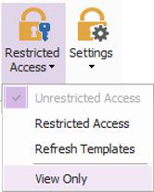
- If you do not want to use templates, please click Restricted Access.

- Type your account name and password when you login to the RMS server for the first time.
- Click the to add users who you want to authorize for reading permissions. (If you have an Outlook Email Client, the contact list of Outlook will pop up when you click the
icon. Then you can go on to the More Options step.)

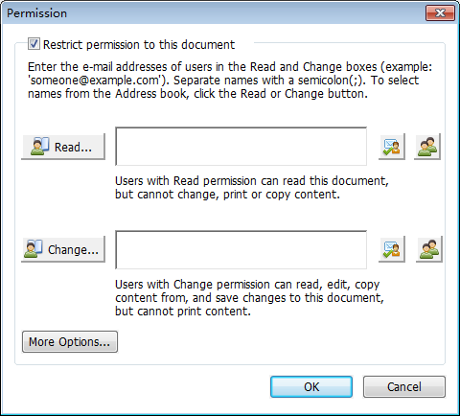

- (Optional) Click More Options in the Permission dialog box. The users you selected now will be shown on the text box. You can also add or delete users as needed here. Specify the permissions as needed and click OK.

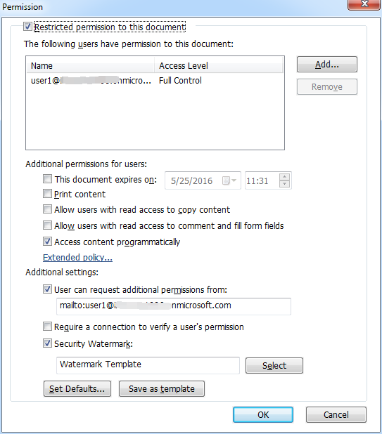

- Click OK and save the changes. The document will be protected by the permissions you just set.

Note: Foxit PhantomPDF also supports Microsoft IRM Protection Version 2, which allows PDF documents to be encrypted to PPDF format. The encryption policy of Microsoft IRM Protection Version 2 does not include dynamic watermark, extended policy, and dynamic revocation.

Template Creation and Editing

To create a custom template, please see the following steps:

- Choose Protect > Settings > Custom Templates.

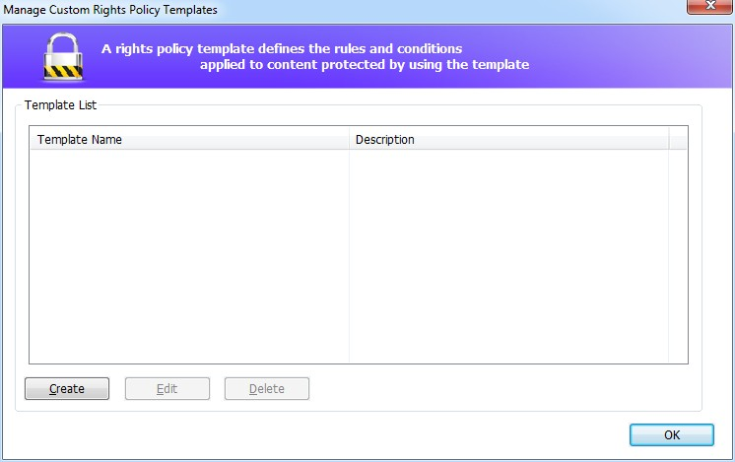
- Click Create to open the Create Custom Rights Policy Template dialog box. (If you want to edit the existing template, please click Edit.) Set the custom permission settings in the four steps during template creation.
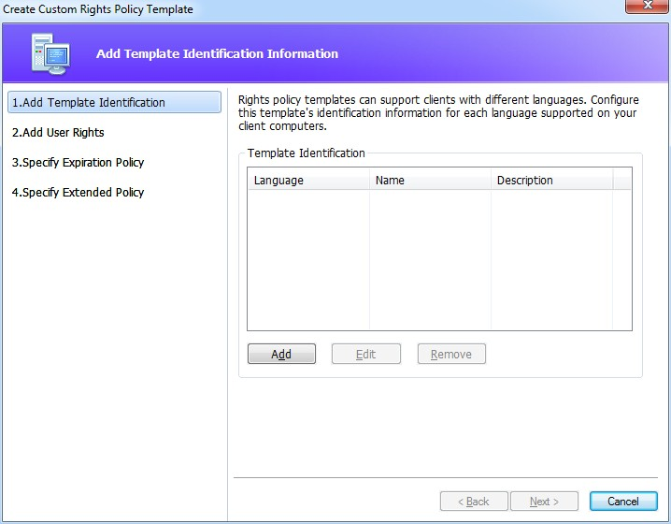
To create a security watermark in the fourth step (Specify Extended Policy), please refer to Security Watermark.

Security Watermark

Creating Profile

Before adding a watermark, you should create a profile first. You can only choose a profile and not a specific watermark to add when applying to a PDF in the same profile.

Choose Protect > Settings > Security Watermark. Click New Profile to create a profile and name it.

Fill in the watermark’s content in the text box and set the font, size, color, underline, and alignment.

Note: you can only set text as watermarks.
Choose the Dynamic Text. When any PDF reader opens the file, the watermark will show the current document information dynamically. You can use multiple dynamic texts at the same time.

Set the appearance by choosing the rotation degree and the opacity. You also have the option to make the scale relative to the target page.

Set the vertical and horizontal distance between the target page and the watermark.

Choose the page range to apply the watermark. You can select the different page range options by selecting from the subset list.

Preview the watermark in the right pane. Click OK to finish.

Foxit Configuration Tool

Foxit PhantomPDF RMS protector provides a handy configuration tool for administrators to better modify the protection settings on an RMS server. Administrators can directly enable/disable each tool, edit the extended policy of official templates, dynamically revoke permissions, audit logs, set valid network printers, and customize wrapper files.
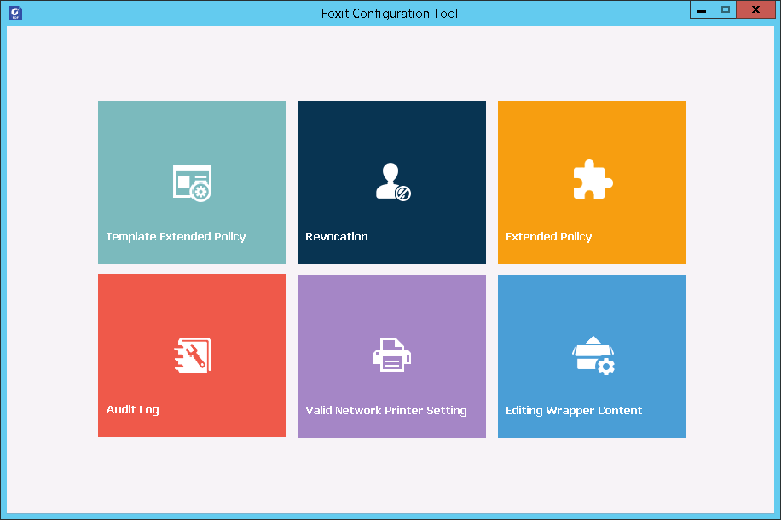

About Signature

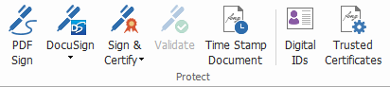

Digital IDs

A digital ID contains two keys; one is a public key (certificate) that is used to encrypt or lock data,

and the other is a private key that is used to decrypt or unlock data that is encrypted.

You can distribute the certificate that contains the public key and other identifying information to those people who need to use it to verify your identity or validate your signature. Only your private key can unlock information that was encrypted using your certificate, so make sure to store your digital ID in a safe place.

Digital IDs are usually protected by password; you can store it on a computer in PKCS#12 file format, or in the Windows Certificate Store. For company-wide deployment, IT managers can also use the SignITMgr tool to configure which digital ID file is allowed to sign PDF files by users across an organization.

Foxit PhantomPDF enables you to create self-signed digital IDs in the following steps:

- Click Sign & Certify > Place Signature in the Protect ribbon, click and drag a signature area. In the Sign Document dialog box, select New ID to create a new one from the dropdown list from Sign As.
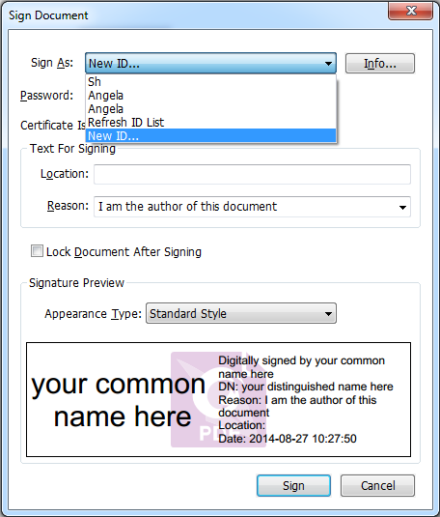

- Choose the location to store your self-signed digital ID.
- Enter your identity information when generating the self-signed certificate.
- Enter a file location and password for your new digital ID file.

Signing documents

Before you sign a document, you need to draw a signature field where the signature is placed, get a digital ID, and create the signature.

You can click Sign & Certify > Place Signature in the Protect tab to finish signing.

A PDF is signed to indicate your approval. The signature will not be resized and moved when you sign the document. Multiple people can sign a PDF more than once. When you sign a document, your digital signature appears in the signature field. The appearance of the signature depends on your preferences.

Certifying a PDF (Available in Business Only)

Only the author can certify his/her own PDF documents. The author can specify what changes can be made to the file after certifying. Whenever approved changes are made, the certificate remains valid. If a reader tries to make changes you haven't allowed, the certificate is invalidated and any subsequent users will be notified that the document was tampered with.

Add a time stamp to digital signatures and documents

Time stamps are used to specify the date and time you signed a document. A trusted time stamp proves that the contents of your PDFs existed at a point-in-time and have not changed since then. Foxit PhantomPDF allows you to add a trusted time stamp to digital signatures or documents.

Before adding a time stamp to digital signatures or documents, you need to configure a default time stamp server. Go to File > Preferences > Time Stamp Servers, and set a default time stamp server. You can then sign the document by placing the digital signature, or by clicking Protect > Protect > Time Stamp Document to add a time stamp signature to the document. You need to add the time stamp server into the trusted certificate list so the properties of digital signatures will display the date/time of the time stamp server when the document was signed.

To add a trusted time stamp server to the Trusted Certificates list, click Timestamp Properties in the lower left corner of the Signature Properties dialog box. In the pop-up Timestamp Properties box, click Add to Trusted Certificates. If a time stamp signature was added in the document, you can right-click the timestamp signature in the Digital Signature panel and choose Show Signature Properties. In the pop-up Signature Properties dialog box, click Add to Trusted Certificates.

Quick PDF Signature

Quick PDF Sign enables you to create your self-signed signatures and add the signatures to the page directly. You don’t need to create different signatures for different roles.

To create your own handwritten signature and sign a PDF, follow these steps.

- Choose Protect > Protect > PDF Sign. The PDF Sign tab appears on the toolbar.
- Click in the signature palette or click on the lower right corner of the signature palette and choose Create Signature from the drop down menu.

- In the Create Signature dialog box, you can draw a signature, import a file, copy from the
clipboard, or type text content to create a signature. Or, click Online Signature to choose a signature from the online signatures you saved before.

TIP: You can sign your signature on a clean white sheet of paper using a black pen, and scan it to an image file. To create the best signature, it is suggested to scan your signature in monochrome at 600 DPI.

- You can preview the signature in the Preview box.
- Check the options as needed:
Convert signature to black & white: the signature will be created in black and white even if the original image is chromatic.
Discard the signature when program closes: the signature will not be listed in the signature palette next time you launch PhantomPDF.
Require password to use this signature: Specify a password that will be required when users sign the document with the signature. Enter the password again to confirm it.
- (Optional) Click Save Online to save the newly created signature to Foxit ConnectedPDF Web Services, which allows you to sign documents.
- Click Save. The cursor will be changed into a shape with the appearance preview of the signature.
- Place the cursor to the position you want to sign and click. Click the signature, and it will be highlighted with a red rectangle. You can move the signature by dragging the rectangle to other places. You can also resize it by clicking and dragging the handle in the lower right corner of the rectangle. When you click the signature, a gray toolbar appears over the rectangle. Click and to switch among different signatures if any; click the invert triangle to drop

down the context menu.
- (Optional) Click Predefined Text > Set Predefined Text to define text that can be integrated in the signature. Using the Typewriter command and the predefined text, you can quickly add some static information (like the full names of the signature owner and the company) which can be integrated in the signature. Flatten the document when applying the signature to prevent the information from being edited. By default, the identity information has been saved as predefined text.
- Select Place on Multiple Pages from the context menu to place the signature to multiple pages.
- To apply the signature to the document, click the rectangle and the invert triangle or
right-click the signature, and select Apply Current Signature from the context menu. You can apply all signatures in the document by clicking Apply All Signatures. A dialog box will pop up when you click Apply All Signatures for the first time to prompt you that applying all signatures will flatten the whole document. You can change the settings by clicking Change Setting in the dialog box, or clicking the invert triangle in the signature palette and choosing Setting, or directly navigating to File > Preferences > PDF Sign.
- Click the Close  button to exit the PDF SIGN tab.
Note: Once applied, the signature can no longer be edited or deleted.

To manage the created signatures, do the following:

In the PDF SIGN tab, click
on the lower right corner of the signature palette and choose
Manage Signature from the drop down menu. In the Manage Signature dialog box, you can create, move and delete the created signatures, and set password for them.

Redaction (Available in Business Only)

The Redaction feature allows you to remove sensitive information from your document prior to making it available to others. You are able to mark the text or graphics for redaction first, and then apply the redaction to the current page or multiple pages.
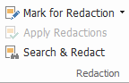

Note: This operation cannot be undone and the selected content will be removed permanently when you select Apply. It is recommended that you save a backup copy of this document before you apply the redaction.

Sanitize Document

Foxit PhantomPDF supports the removal of hidden information that is private or sensitive for users from their PDFs, generally including metadata, embedded content, attached files, and scripts.
To remove hidden information from PDFs, please go to Protect > Hidden Data > Sanitize Document.

Generate Redacted and RMS-protected PDFs (Business Only)

Foxit PhantomPDF enables users to generate a redacted and RMS-protected PDF from an existing PDF. Authorized users are granted access to view the full document while unauthorized users are only able to view the redacted document, which allows for improved sharing of non-sensitive information within a protected document.
To generate a redacted and RMS-protected PDF, please do the following: Mark the text for redaction.

Click Protect > Redaction > Protect Redactions , log on your RMS server and then choose an RMS template to encrypt the document.

ConnectedPDF

Foxit ConnectedPDF allows each PDF to carry an identity assigned by the cPDF cloud service, and tracks all the events on the PDF like creation, distribution, and modification. So no matter where the ConnectedPDF document goes, how many distributions and modifications done to it, the document owner can always track the document in real time and collaborate with the document viewers involved. Therefore, ConnectedPDF connects files, people, location, and systems together

while ordinary PDF is separate and static.

The Connect tab in Foxit PhantomPDF toolbar provides powerful and easy-to-use commands to create, protect, and track the access to Connected PDFs. You can also start and join a shared review on Connected PDFs without any server anytime anywhere. The detailed features include:

  - Convert PDF to ConnectedPDF
  - Convert other formats to cPDF when creating to PDF
  - Configure open messages which appear when other users open a ConnectedPDF document (Business only)
  - Clone a document (Business only)
  - Enable document enforced tracking (Business only)
  - Track any access to cPDF documents
  - Show usage data in document homepage
  - Register and upload a new version of cPDF document
  - Send update notification when registering a new version (Business only)
  - Share a file by generating a file link and sending it via email or to social media
  - Online ConnectedPDF protection (Business only)
  - Permission configuration
  - Dynamically approve and revoke document permission
  - Dynamically request document permission and response to the changes of document permission
  - Connected shared review without having to set up a shared folder
  - Document locator and request

For more information about ConnectedPDF, please refer to ConnectedPDF User Manual.

Accessibility

Foxit PhantomPDF provides accessibility features to give users with disabilities (such as visually impaired people) greater access to information and technology. With commands in the Accessibility tab in the ribbon and the panels related to accessibility in the navigation pane, you can check the accessibility of PDFs, fix accessibility issues, edit document structure, and set accessibility preferences to make PDFs and the setup more accessible.
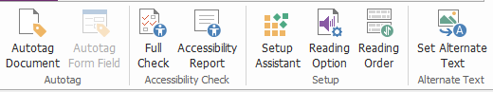

The Accessibility Tab in Business Edition

- Accessibility check and fixes
- Accessible reading and navigation
- Create accessible PDFs (Business only)

Accessibility check and fixes

Use the Full Check command to check whether a PDF is compliant with accessibility standards of Web Content Accessibility Guidelines (WCAG) 2.0. You can choose which kinds of accessibility items to check for and how to view the results. When the check is completed, the Accessibility Check panel automatically expands in the navigation pane to display the check results, then you can right- click an item and choose one of the options from the context menu to deal with the accessibility issues.

To view the accessibility report, you can click Accessibility > Accessibility Checker > Accessibility
Report , or directly click the Accessibility Report panel in the navigation pane. The report includes the name of the PDF document, Summary of the result, and Detailed Report for each checking option. Detailed Report clearly lists the rule name, status, and description for each checking option. You can click the links in the report to view the online Help on fixing accessibility issues.

Accessible reading and navigation

Foxit PhantomPDF allows you to set accessibility preferences that control the document colors, document display and reading order, and provides keyboard shortcuts, which are good for visually impaired and motion-impaired users to better read and navigate PDFs with or without assistive software/hardware.
Use the Setup Assistant command and follow the onscreen instructions to set accessibility preferences and the Reading Option command to change the reading settings for the current document like reading order and mode.
The reflow view allows users to read documents on a mobile device or even a screen magnifier without scrolling horizontally to read text by presenting pages as a single column that is the width of the document pane. To read PDF in reflow view, choose Home > View > Reflow, or choose View > Document Views > Reflow.

Create accessible PDFs (Business only)

Accessible PDF documents have content and elements including searchable text, alternate text descriptions for images/interactive form fields, reading order, and document tags, to enable people with disabilities to work on them with or without screen readers or other assistive software/hardware. Foxit PhantomPDF provides commands and panels to help make your PDF accessible by tagging PDFs and form fields, setting alternate text, editing tags, and more.

You can use the Autotag Document command and the Autotag Form Field command to quickly tag PDF documents and form fields. You can view the tags created in the Tags panel in the navigation pane.

To set alternate text for figures in your PDF, click Set Alternate Text. The alternative text of a figure can be displayed when you hover over your mouse over the figure to help you understand the figure better.

The Reading Order command helps you easily edit tags for PDFs. Click Reading Order, check Show page content groups and choose Page content order/Structure types in the dialog box in the Touch Up Reading Order dialog box, and you can see highlighted regions that are numbered or labeled with structure types in the document area. To edit tags, draw a rectangle in the page content or click the number of a highlighted region, and choose a tag type from the Touch Up Reading Order dialog box. You can change the reading order by moving tags in the Order panel. For the content reflow and tagging problems that cannot be fixed by the Reading Order command, the Content and Tags panels provide you with more options to handle them.

Contact Us

Feel free to contact us should you need any information or have any problems with our products. We are always here, ready to serve you better.

  - Office Address:
Foxit Software Incorporated 41841 Albrae Street
Fremont, CA 94538 USA

  - Sales:
1-866-680-3668

  - Support & General:
1-866-MYFOXIT, 1-866-693-6948, or 1-510-438-9090

  - Fax:
1-510-405-9288

  - Website:
www.foxitsoftware.com

  - E-mail:
Sales - sales@foxitsoftware.com Marketing - marketing@foxitsoftware.com
Technical Support - enter a trouble ticket via our Support Portal Website Questions - webmaster@foxitsoftware.com

